Here’s a clear, category-wise competitor map for Indriya (Novel Jewels) — this is how leadership (like Panda/CEO) actually sees the market.

🧭 1. Premium / Trust-led National Chains (DIRECT CORE COMPETITORS)
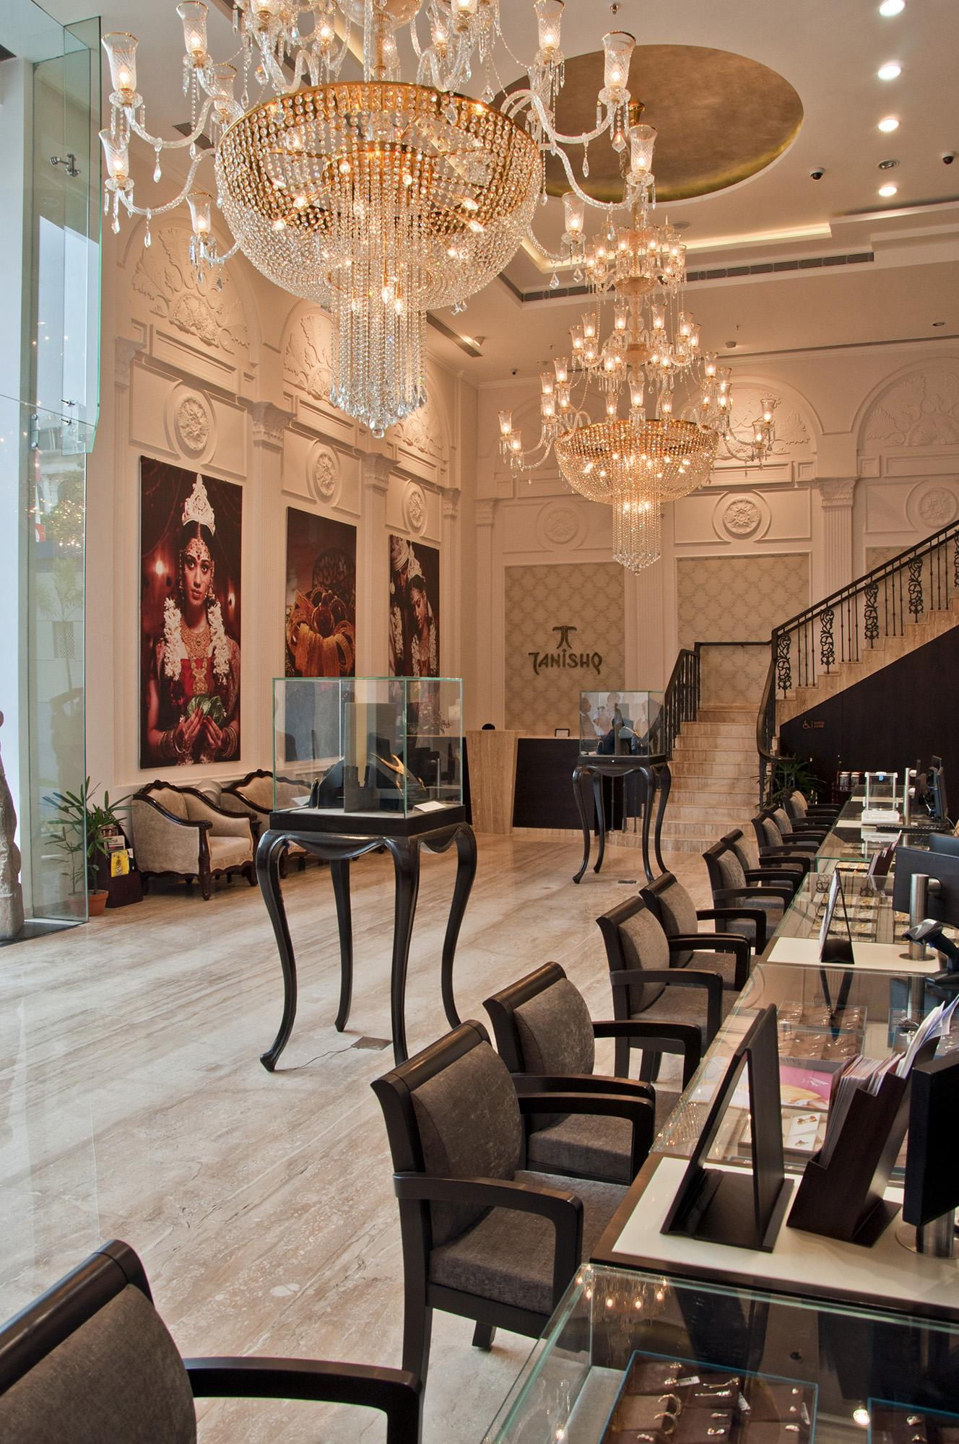
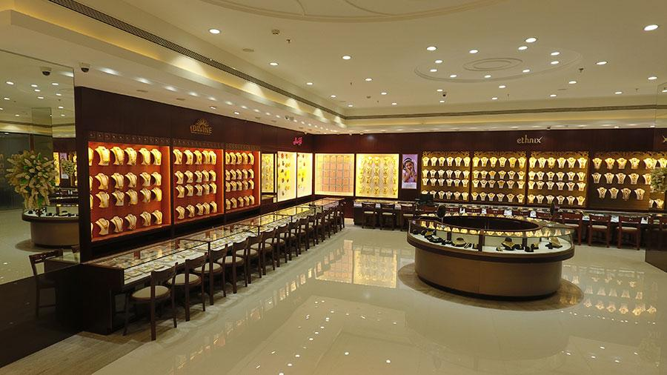
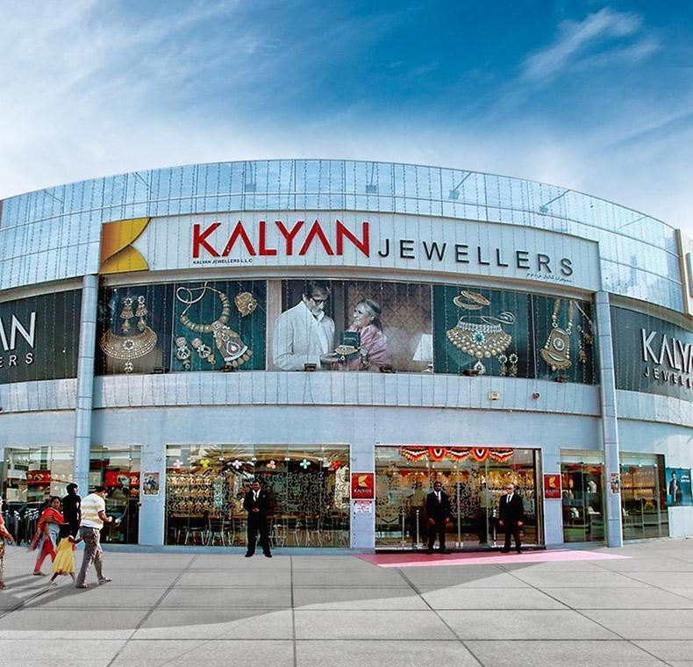
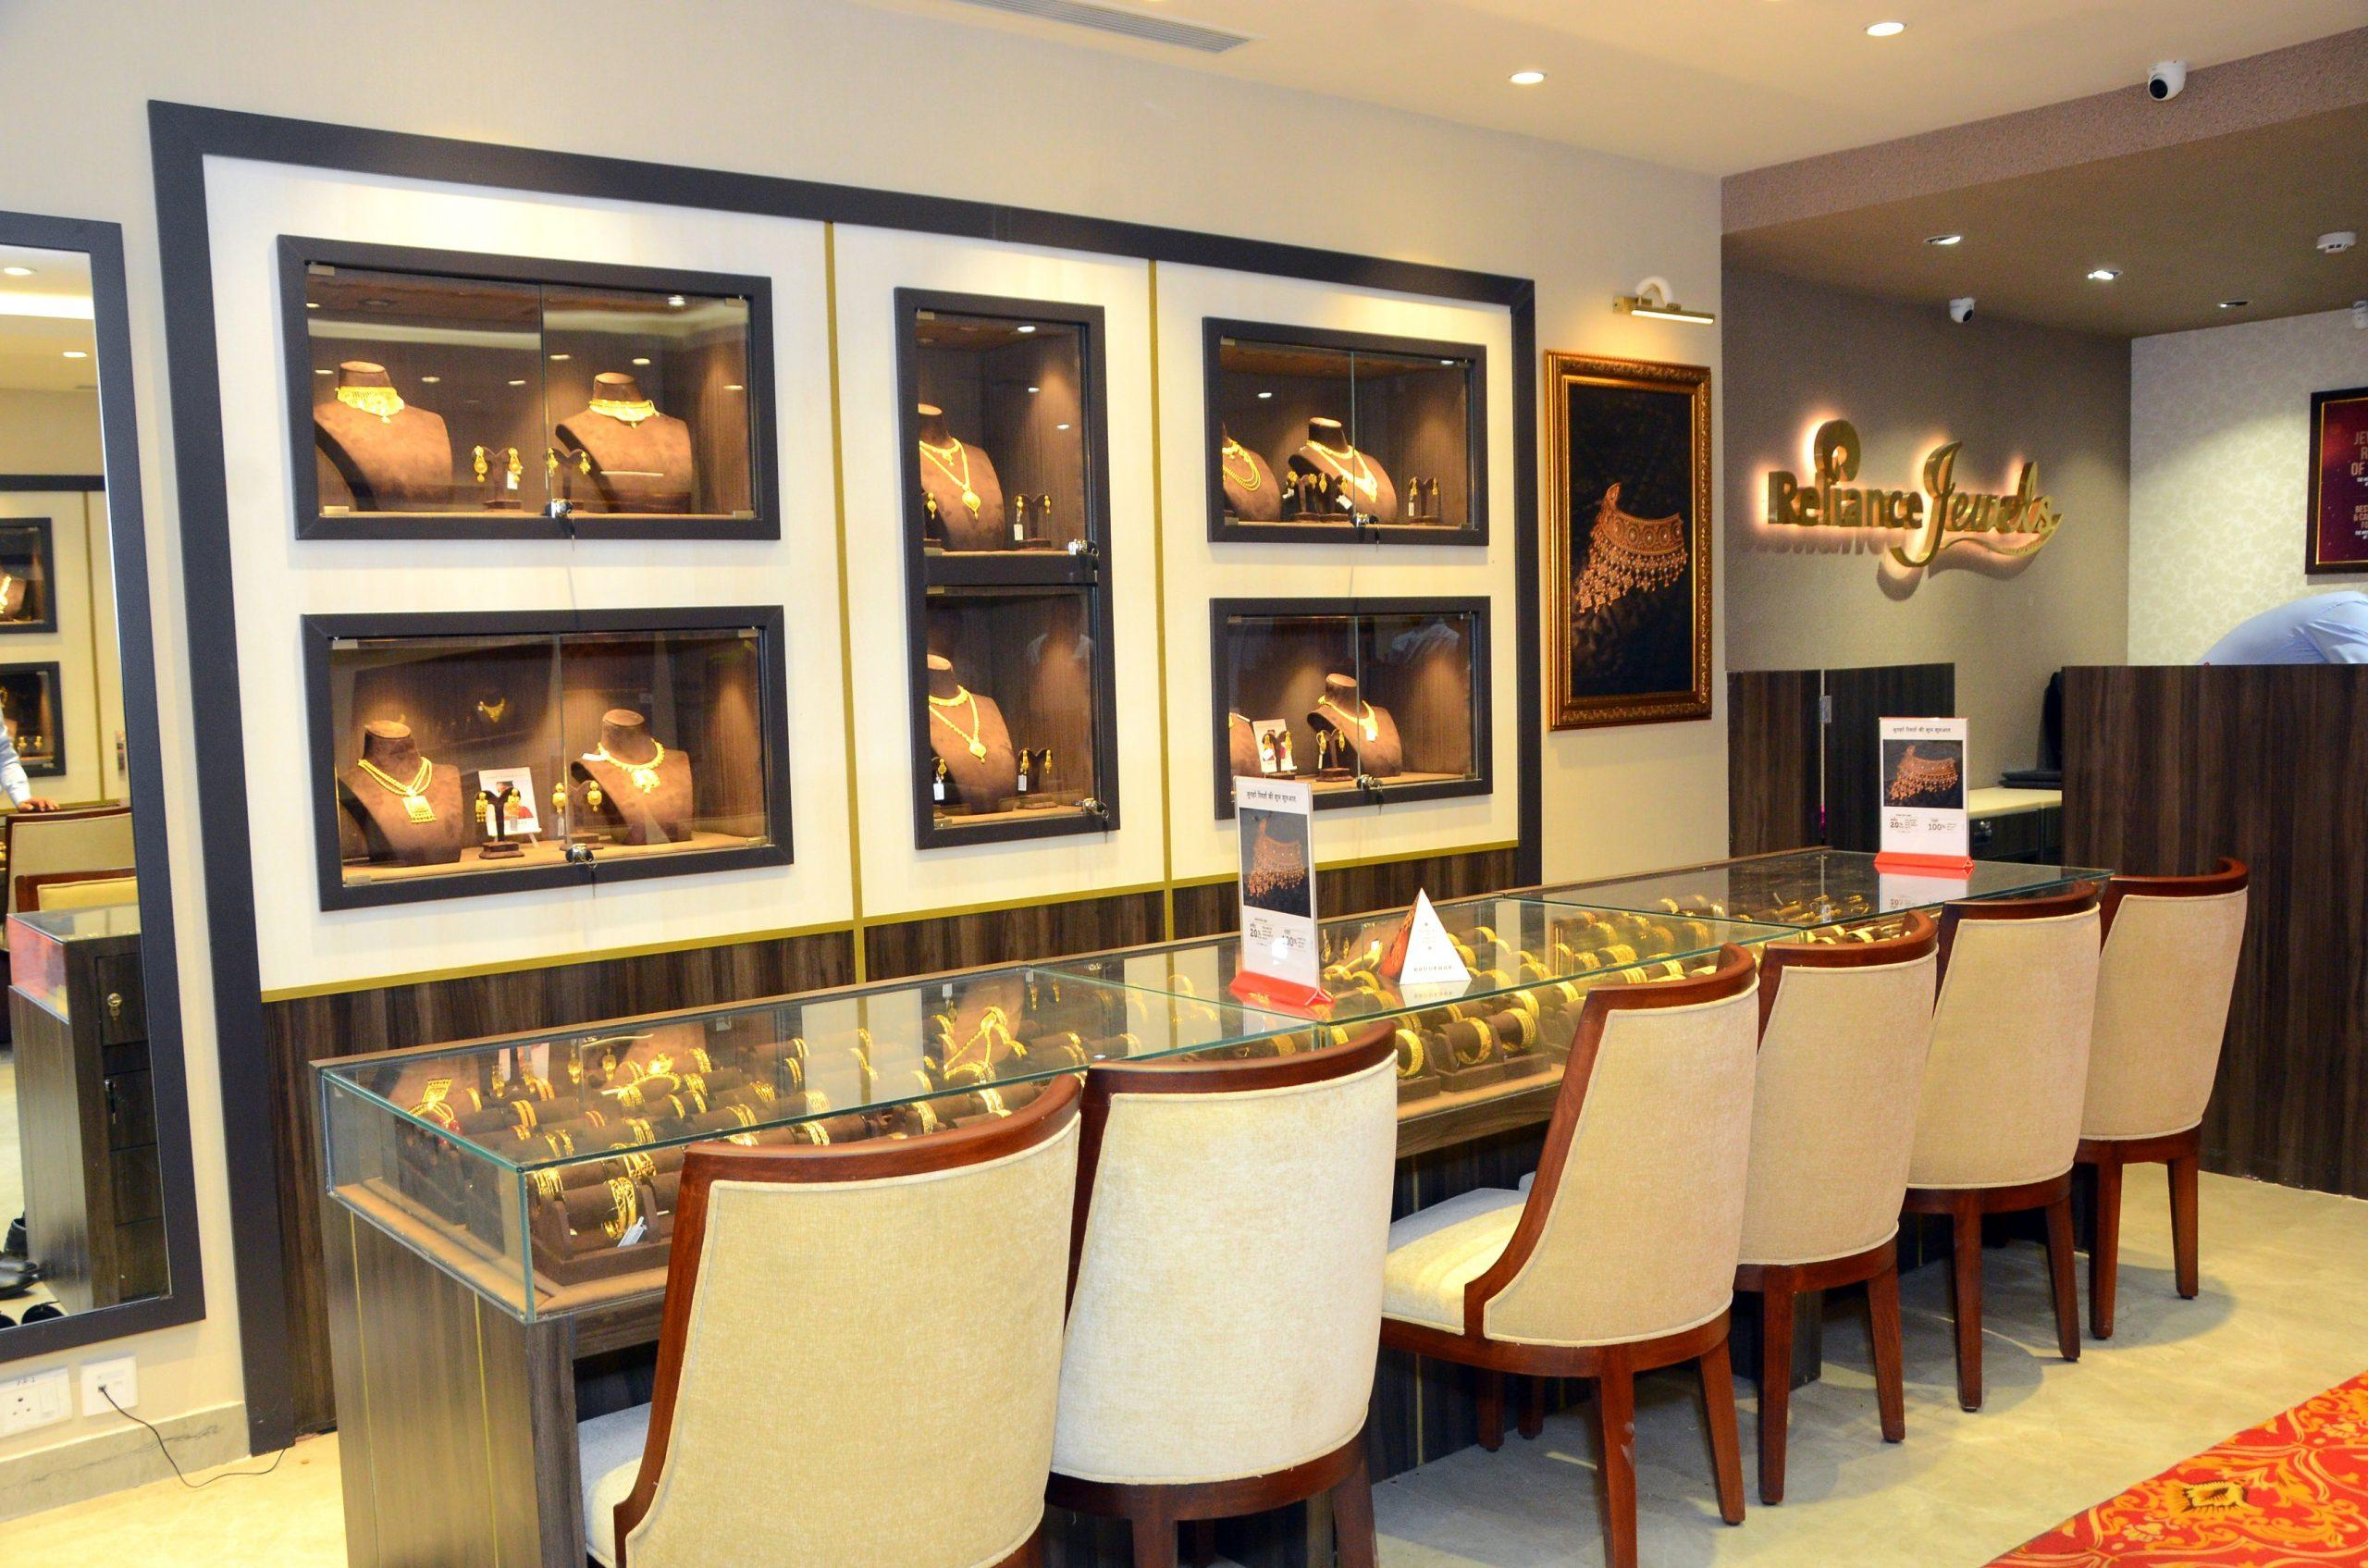
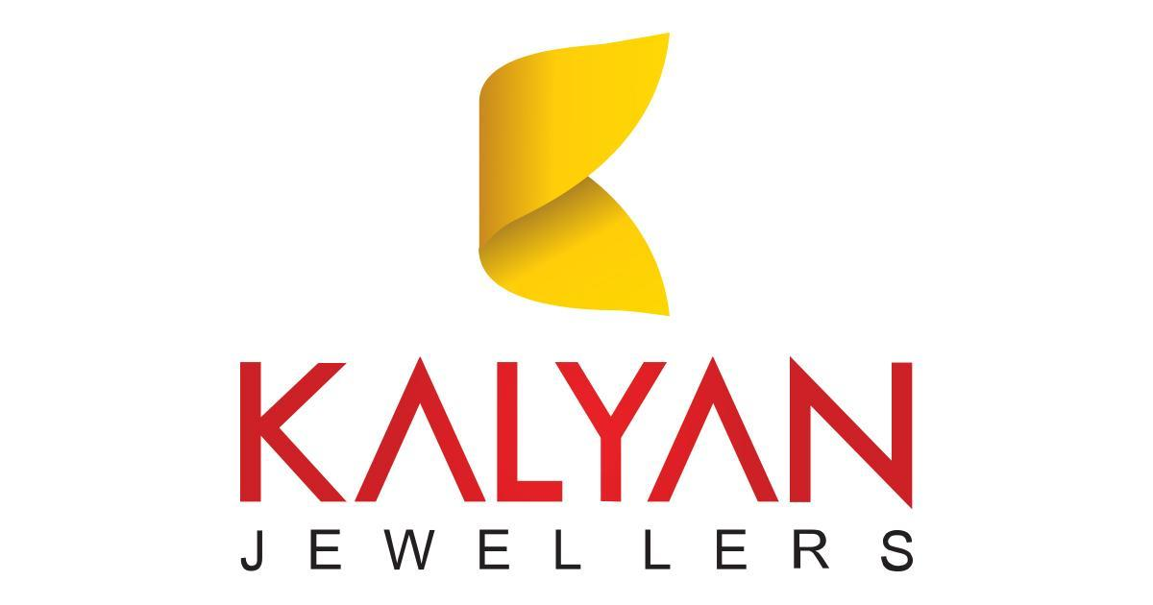
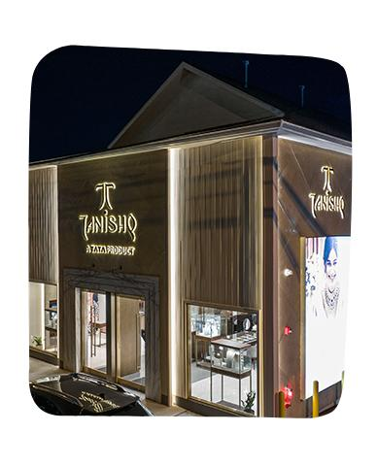
These are the most important competitors for Indriya.
- Titan Company (Tanishq)
- Malabar Gold & Diamonds
- Kalyan Jewellers
- Reliance Jewels

🎯 Why they matter
- Strong brand trust + scale
- Large store networks (hundreds of stores) (Registrationwala)
- Compete directly on:
  - Bridal jewellery
  - Gold purity trust
  - Store experience
👉 Indriya’s main battlefield = here

💍 2. Wedding / Traditional Heavy Jewellery Specialists
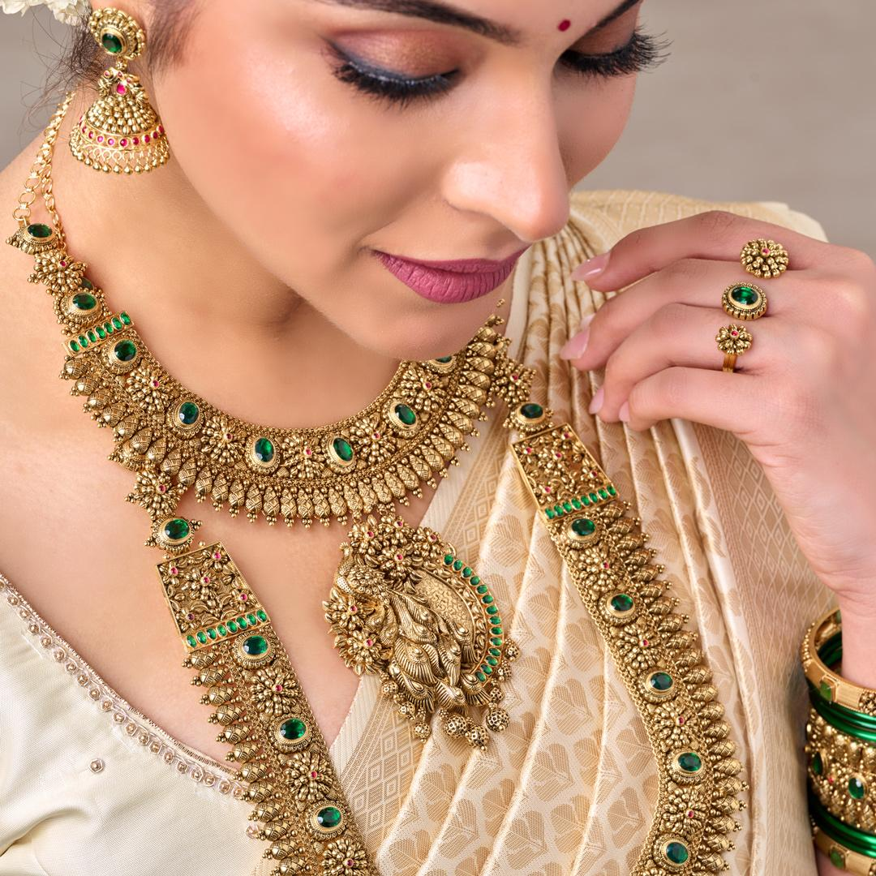
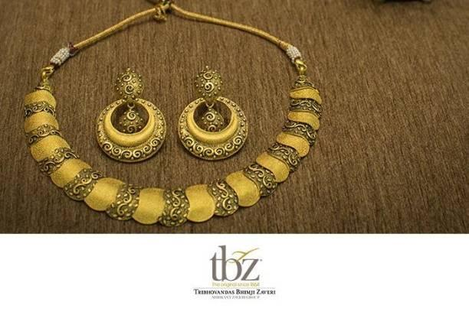
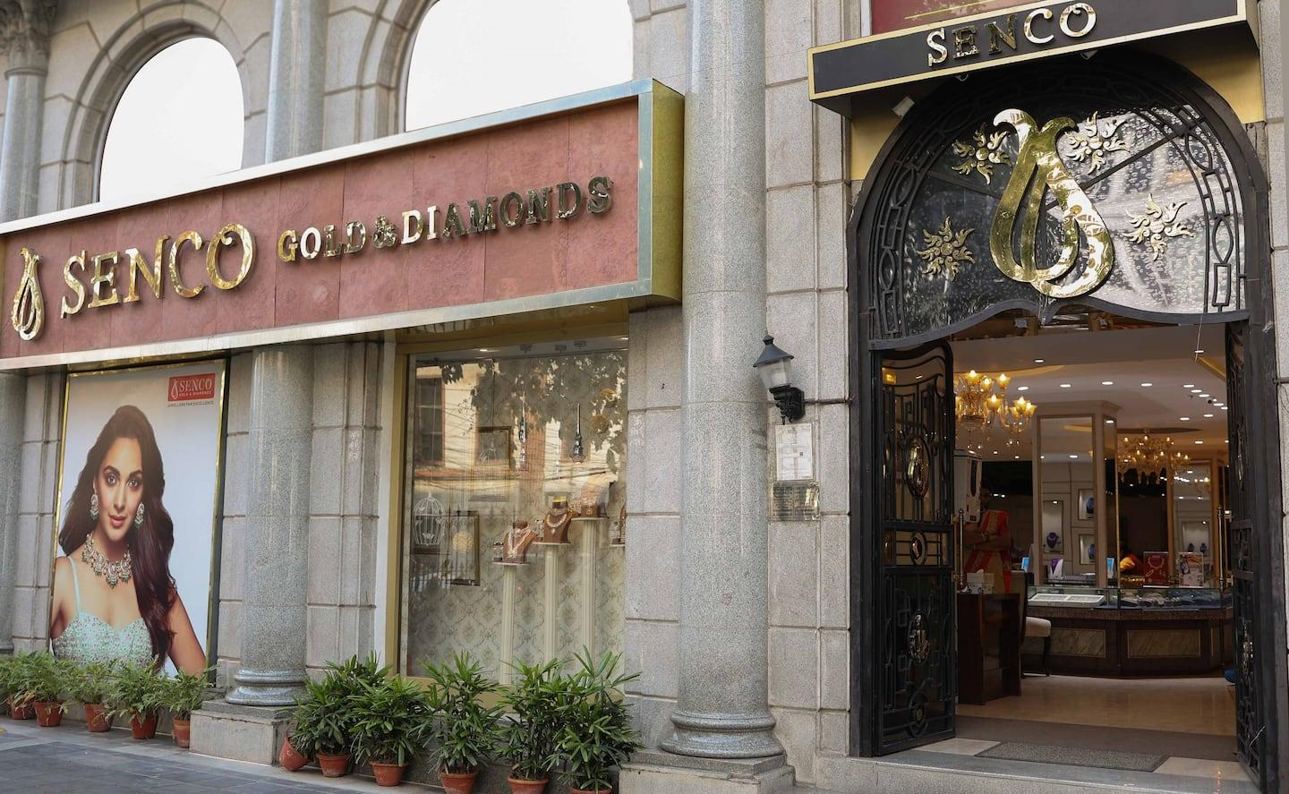
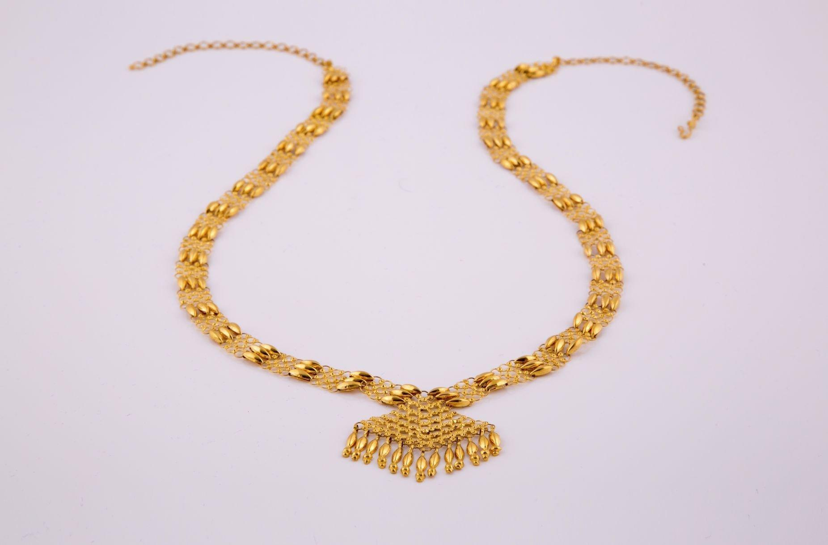
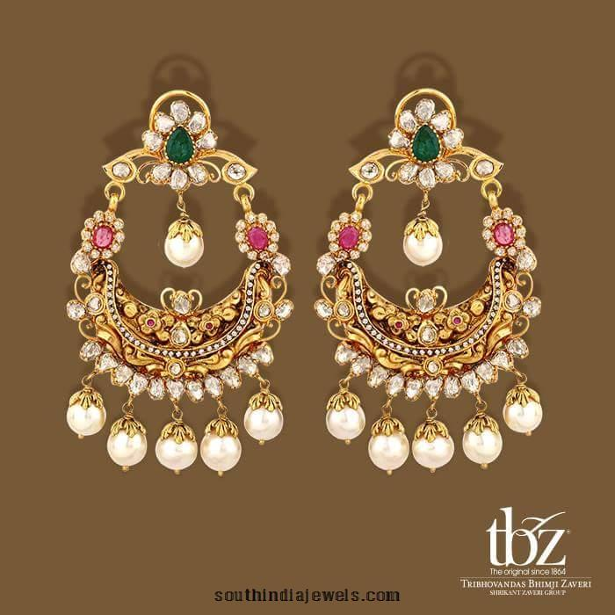
- Tribhovandas Bhimji Zaveri (TBZ)
- Senco Gold & Diamonds
- Joyalukkas
- Bhima Jewellers

🎯 Why they matter
- Strong in bridal & regional dominance
- Deep cultural design expertise
- High-value wedding purchases
👉 Compete with Indriya in:
- Bridal segment (biggest revenue driver)

💎 3. Digital-first / Modern Jewellery Brands
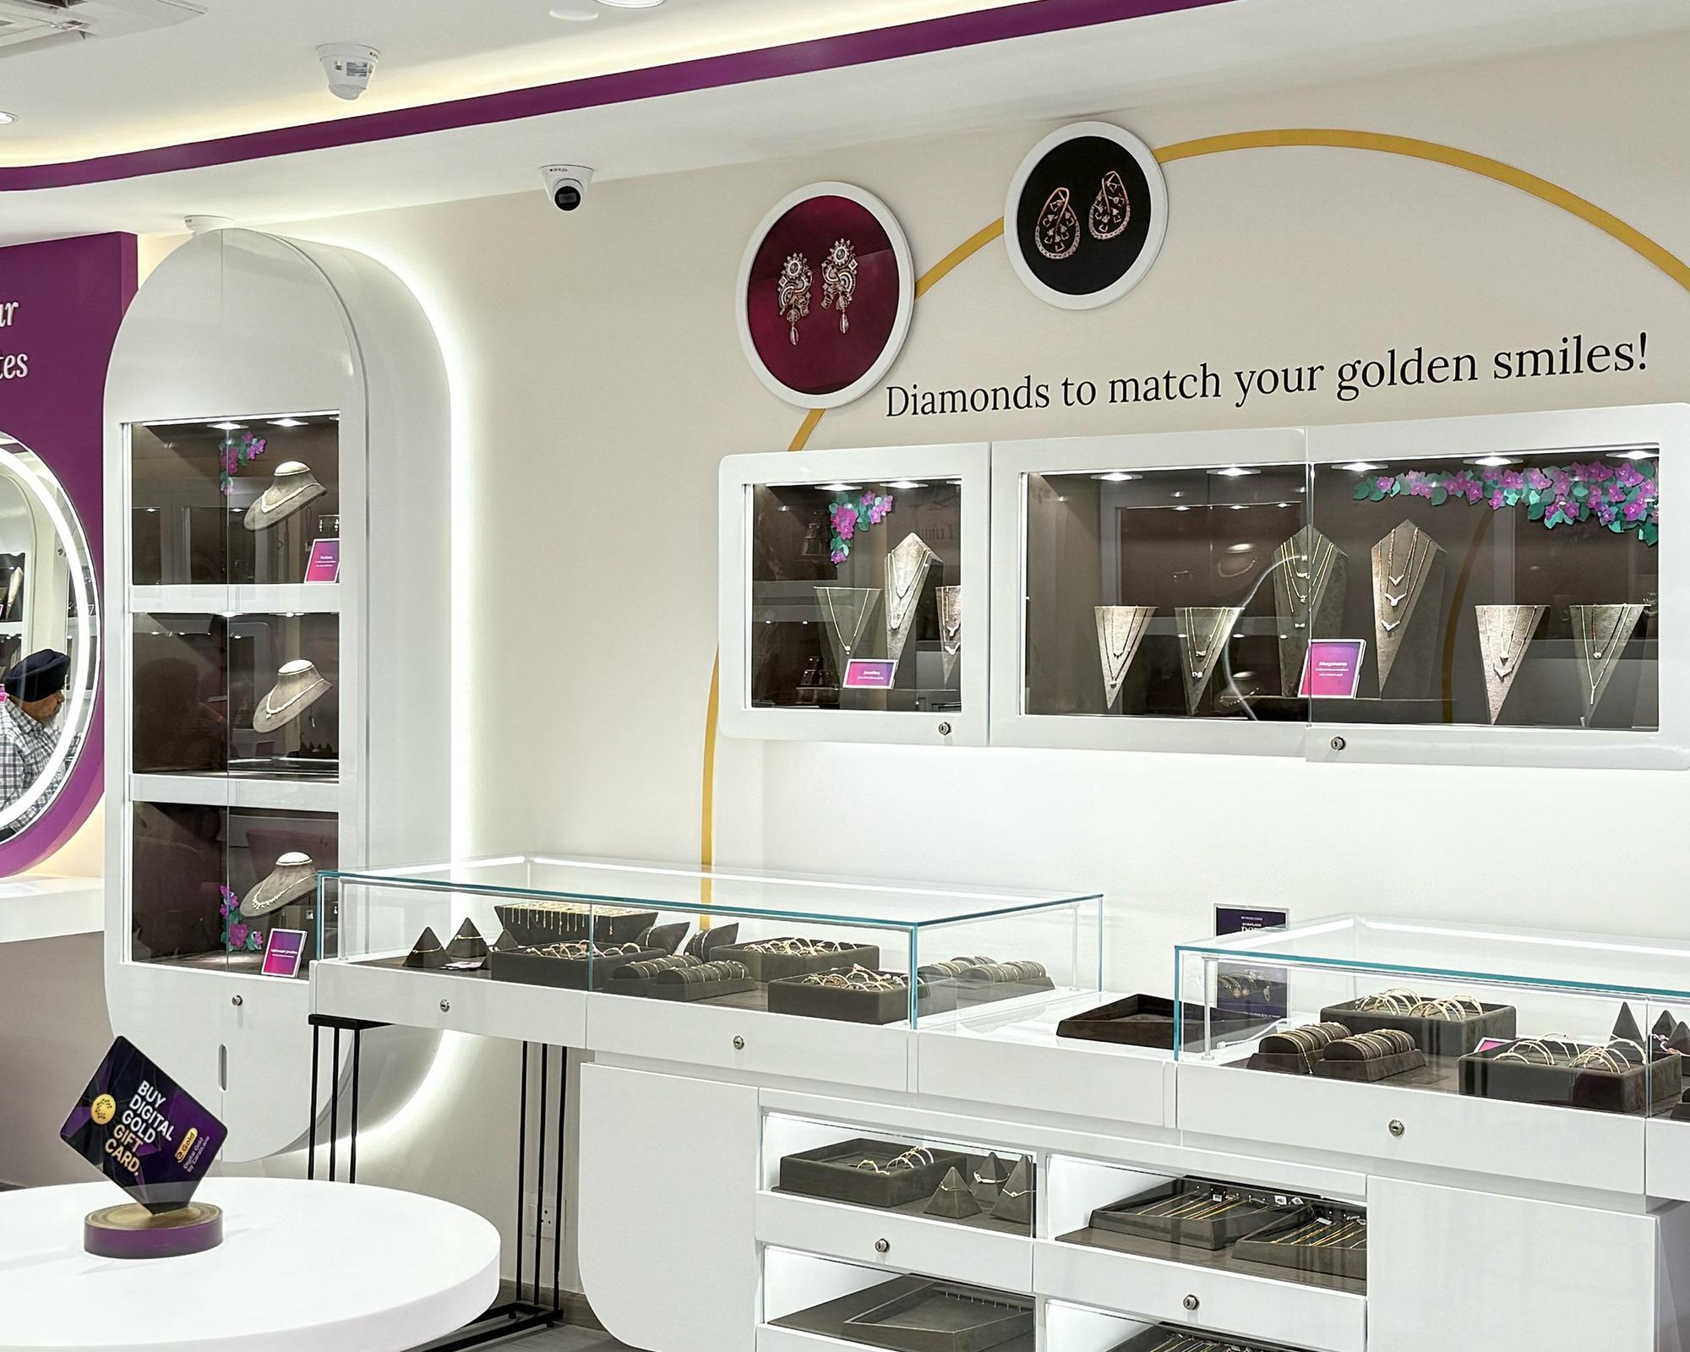
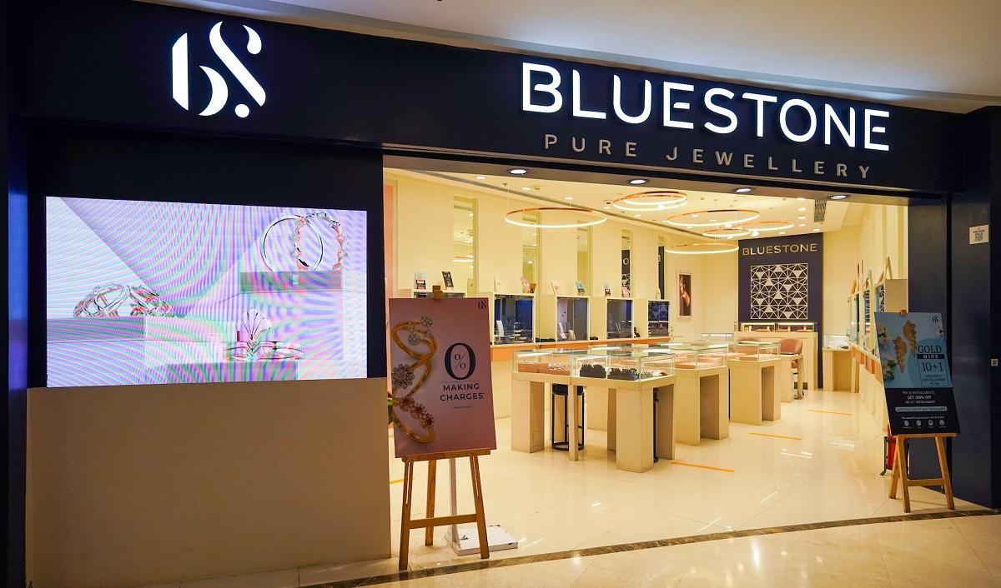
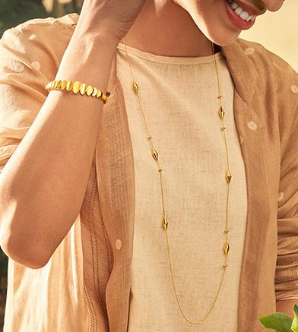
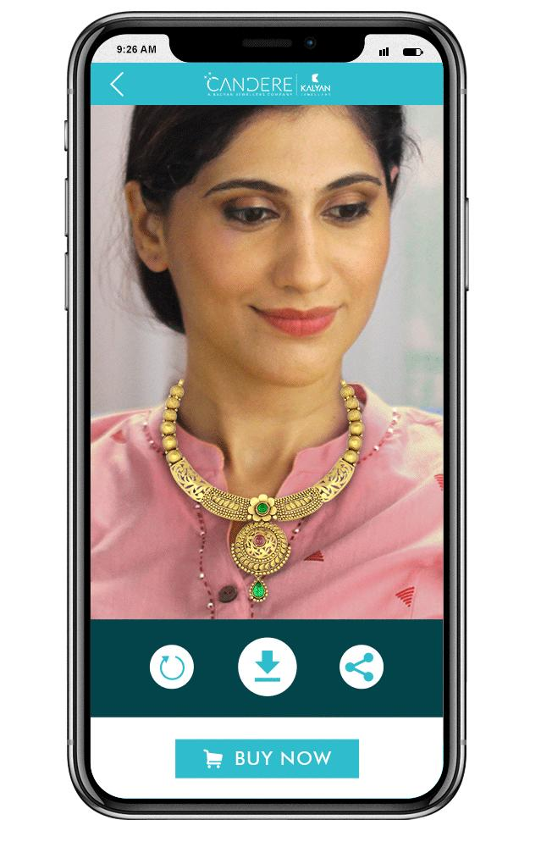
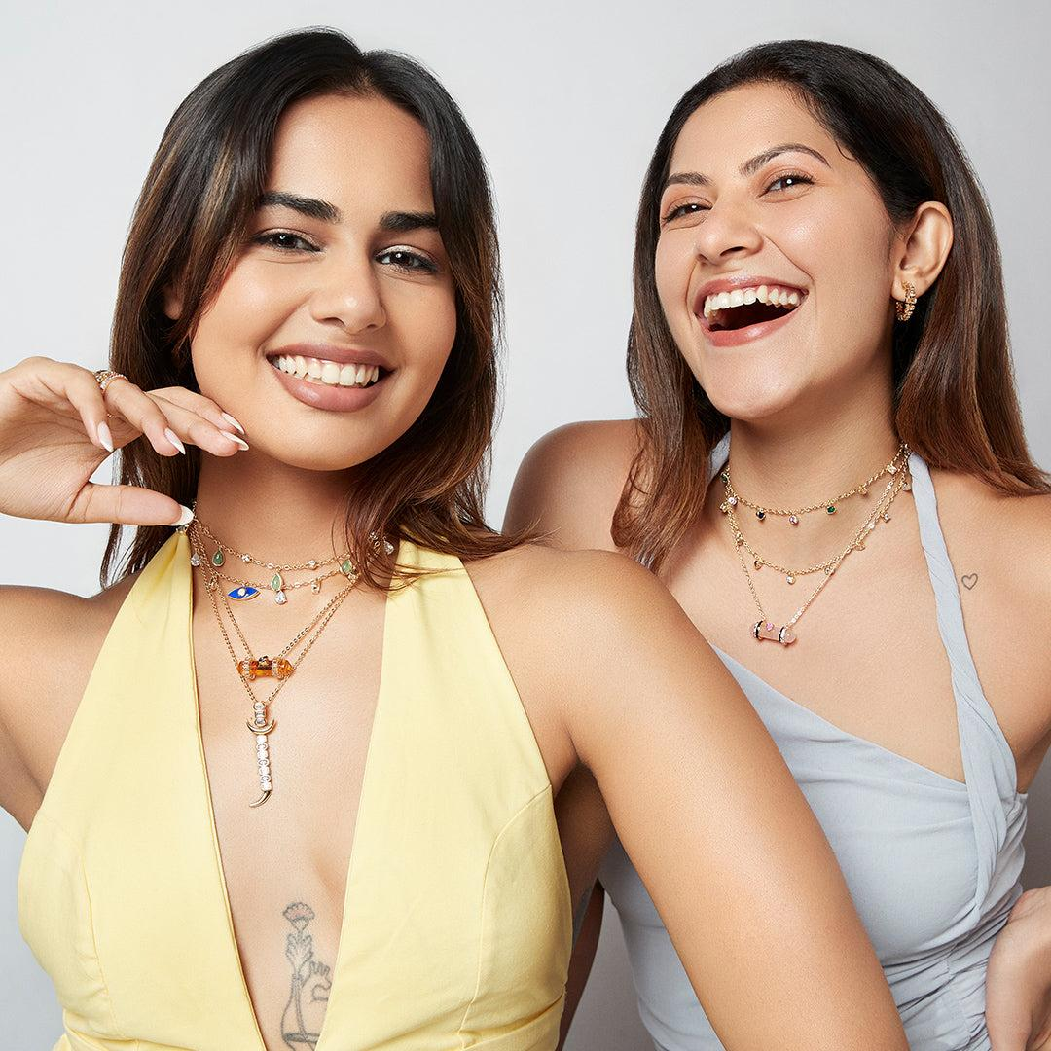

- CaratLane
- BlueStone

🎯 Why they matter
- Strong with:
  - Millennials / Gen Z
  - Lightweight jewellery
- Omni-channel (online + offline)
👉 Threat to Indriya in:
- Everyday jewellery
- Younger audience

🪔 4. Regional Powerhouses (Hidden but STRONG)
- Thangamayil Jewellery
- P.N. Gadgil Jewellers
- Regional South / West India chains

🎯 Why they matter
- Deep local trust
- Strong repeat customers
- Dominant in Tier-2 / Tier-3 cities (gullak.money)
👉 Hard to displace despite weaker branding

💰 5. Unorganized / Local Jewellers (BIGGEST MARKET SHARE)
- Lakhs of local family jewellers across India

🎯 Why they matter
- Still dominate majority of market
- High trust relationships
- Flexible pricing
👉 Biggest long-term disruption target for Indriya

📊 FINAL COMPETITOR MAP (Simple View)
Category | Competitors | Strength
Premium national | Tanishq, Malabar, Kalyan, Reliance | Trust + scale
Bridal specialists | TBZ, Senco, Joyalukkas | Wedding dominance
Digital-first | CaratLane, BlueStone | Young customers
Regional chains | Bhima, PN Gadgil | Local trust
Unorganized | Local jewellers | Price + relationships

⚡ Strategic Insight (VERY IMPORTANT)
👉 Indriya is trying to position as:
“Tanishq + CaratLane hybrid”
- Premium trust (like Tanishq)
- Modern design (like CaratLane)

🔥 One-line summary
👉 Competition is not one brand — it’s 5 different battlefields

If you want next level, I can:
- Compare Indriya vs Tanishq (strategy, pricing, store experience)
- Or show exact gap Indriya is trying to exploit (why Birla entered now)

